Wireshark Ethernet ARP
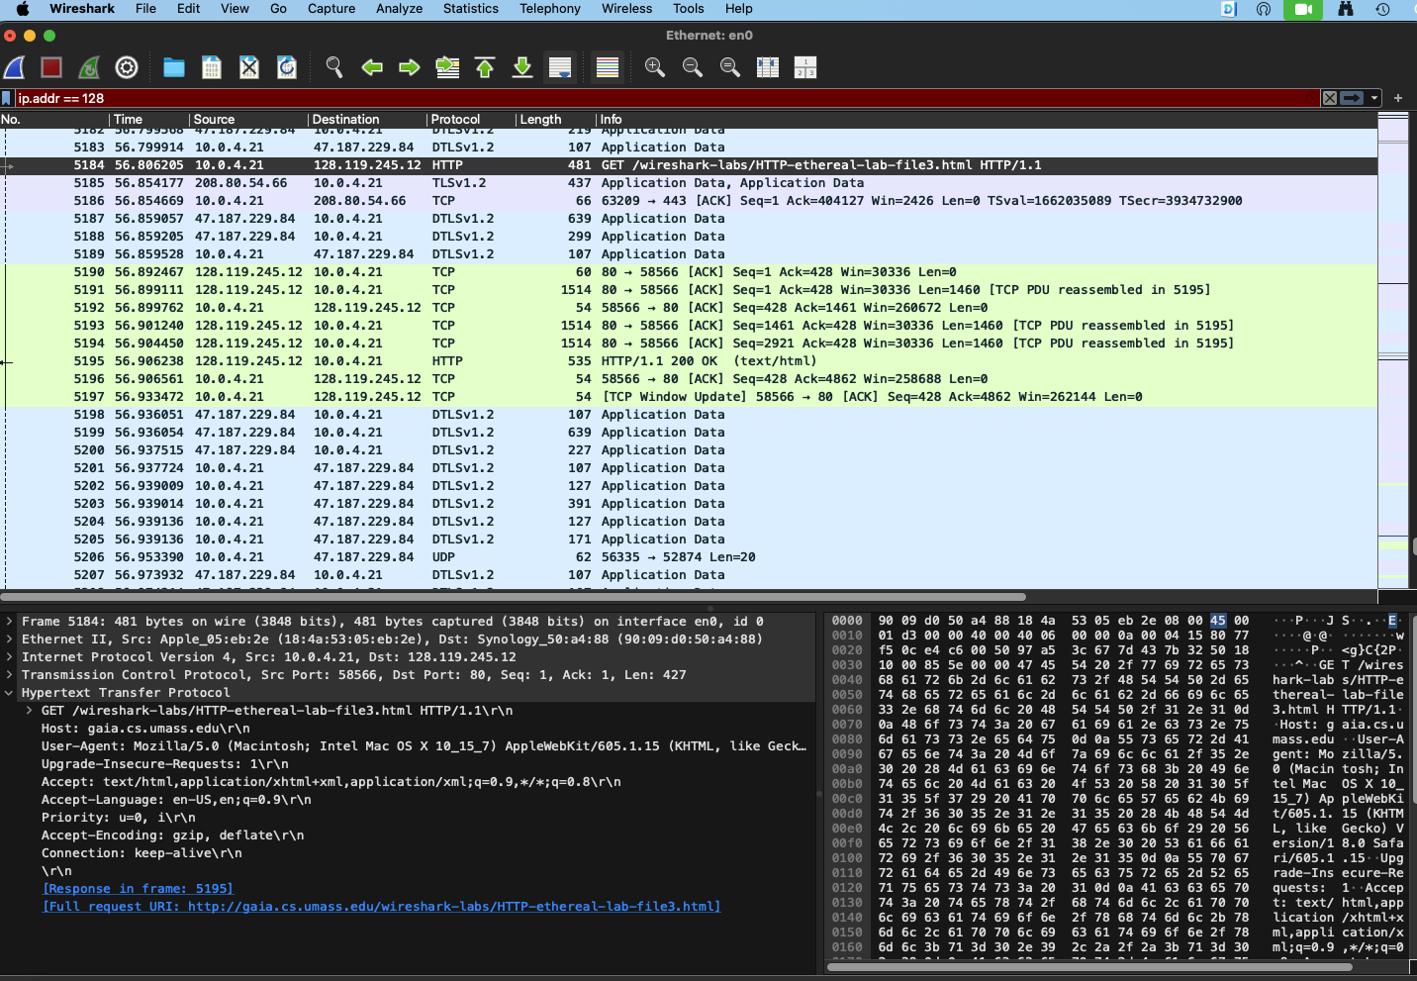

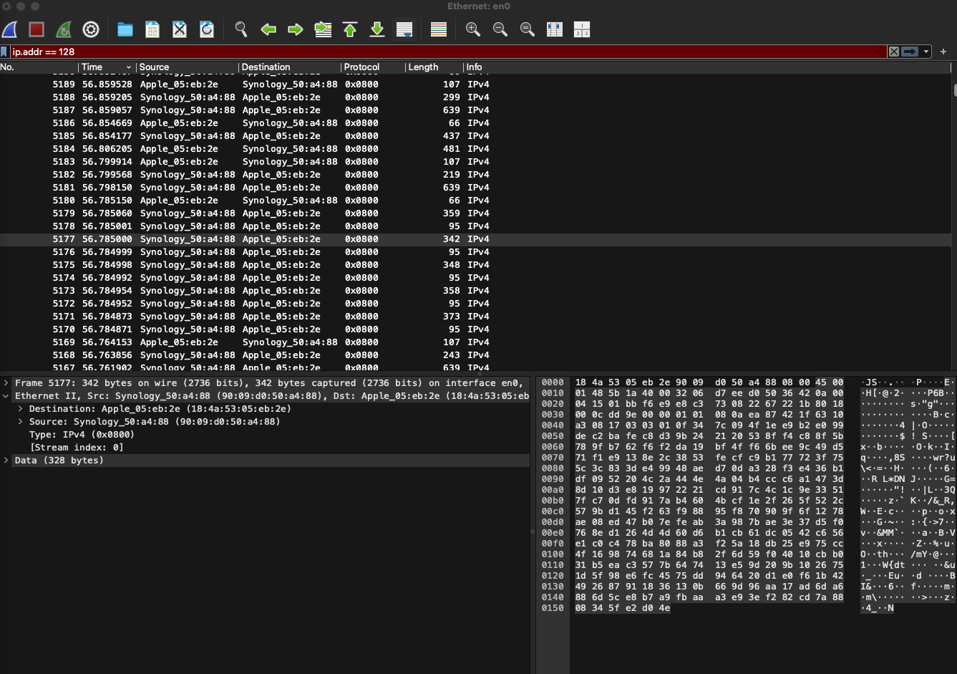

- What is the 48-bit Ethernet address of your computer?
- What is the 48-bit destination address in the Ethernet frame? Is this the Ethernet address of gaia.cs.umass.edu. No.
- How large is the ARP header for a request? What about for a reply?
32 bytes. 32 bytes.
- Give the hexadecimal value for the two-byte Frame type field. What do the bit(s) whose value is 1 mean within the flag field?
0x0806; Frame Type
- How many bytes from the very start of the Ethernet frame does the ASCII “G” in “GET” appear in the Ethernet frame?
54
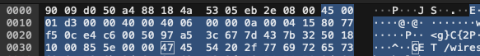

- What is the hexadecimal value of the CRC field in this Ethernet frame?
Bf b8 81 46
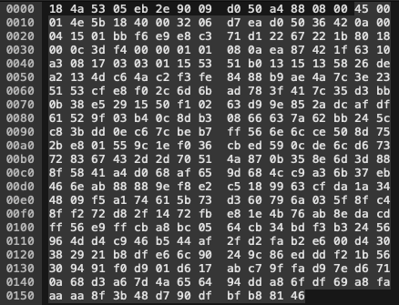
- Is the ARP reply broadcast (like the ARP request) or not? No.

- What Ethernet Type value which indicates that ARP is the higher layer protocol?
0x0806

Next, answer the following questions, based on the contents of the Ethernet frame containing the first byte of the HTTP response message.

- What is the value of the Ethernet source address?
  - Is this the address of your computer? No
  - What device has this as its Ethernet address? My Router.
- What is the destination address in the Ethernet frame?
  - Is this the Ethernet address of your computer? Yes.
- Give the hexadecimal value for the two-byte Frame type field.
  - 0800
  - What do the bit(s) whose value is 1 mean within the flag field?
    - IPv4
- How many bytes from the very start of the Ethernet frame does the ASCII “O” in “OK”
  - 13
- What is the hexadecimal value of the CRC field in this Ethernet frame?
  - 74 6d 6c 3e

